**Chapter 4**

**System Design**

|  |  |
| --- | --- |
|  |  |

**Chapter 4: System Design**

In the previous chapter, we determined the different requirements of the DERMAI . We also

determined the needed tools to build it. Now, we can design the system considering the

determined requirements. In section 4.2, we provide the class diagram which includes the

classes of the system, their attributes, operations, and relations. Then we provide the design of

database tables in section 4.3. The design of the mobile application is included in section 4.4.

**4.1 Class Diagram**

A class diagram describes the structure of a system by showing the system's classes, their

attributes, operations (or methods), and the relationships among objects [24]. Figure 4.1 shows

the class diagram that include classes representing all system components.

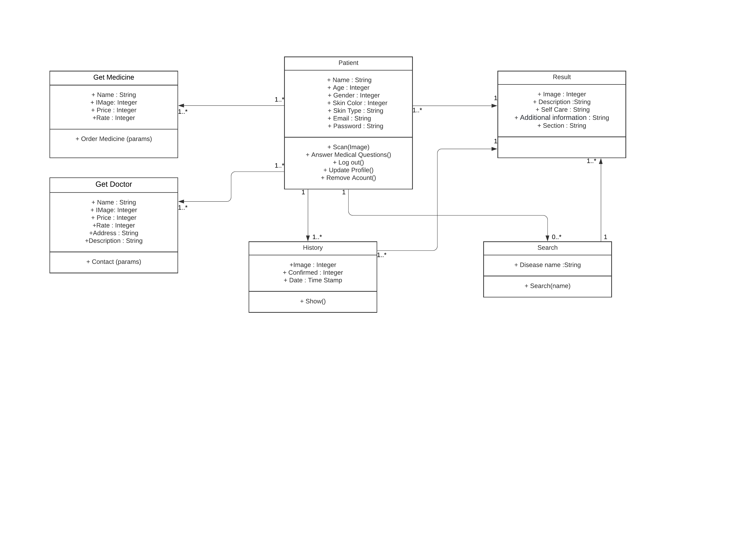

Figure 4.1 Class diagram.

**4.2 Data base Design or Algorithms**

ERD (Entity Relationship Diagram) is a data modeling technique hat graphically

illustrate an information system's entities and the relationship between those entities. This

**ERD show 27 entities and the relationship between them:**   
(Users, disease_result, failed_jobs, notifications, results, settings, answers, attachments, roles, answer_question, medicins, personal_access_tokens, user2_disease, disease2_symptom, category_disease, symptoms, articles, doctors, questions, password_resets, categories, role_users, migrations, attachmentable, diseases, disease2_precaution, precautions)

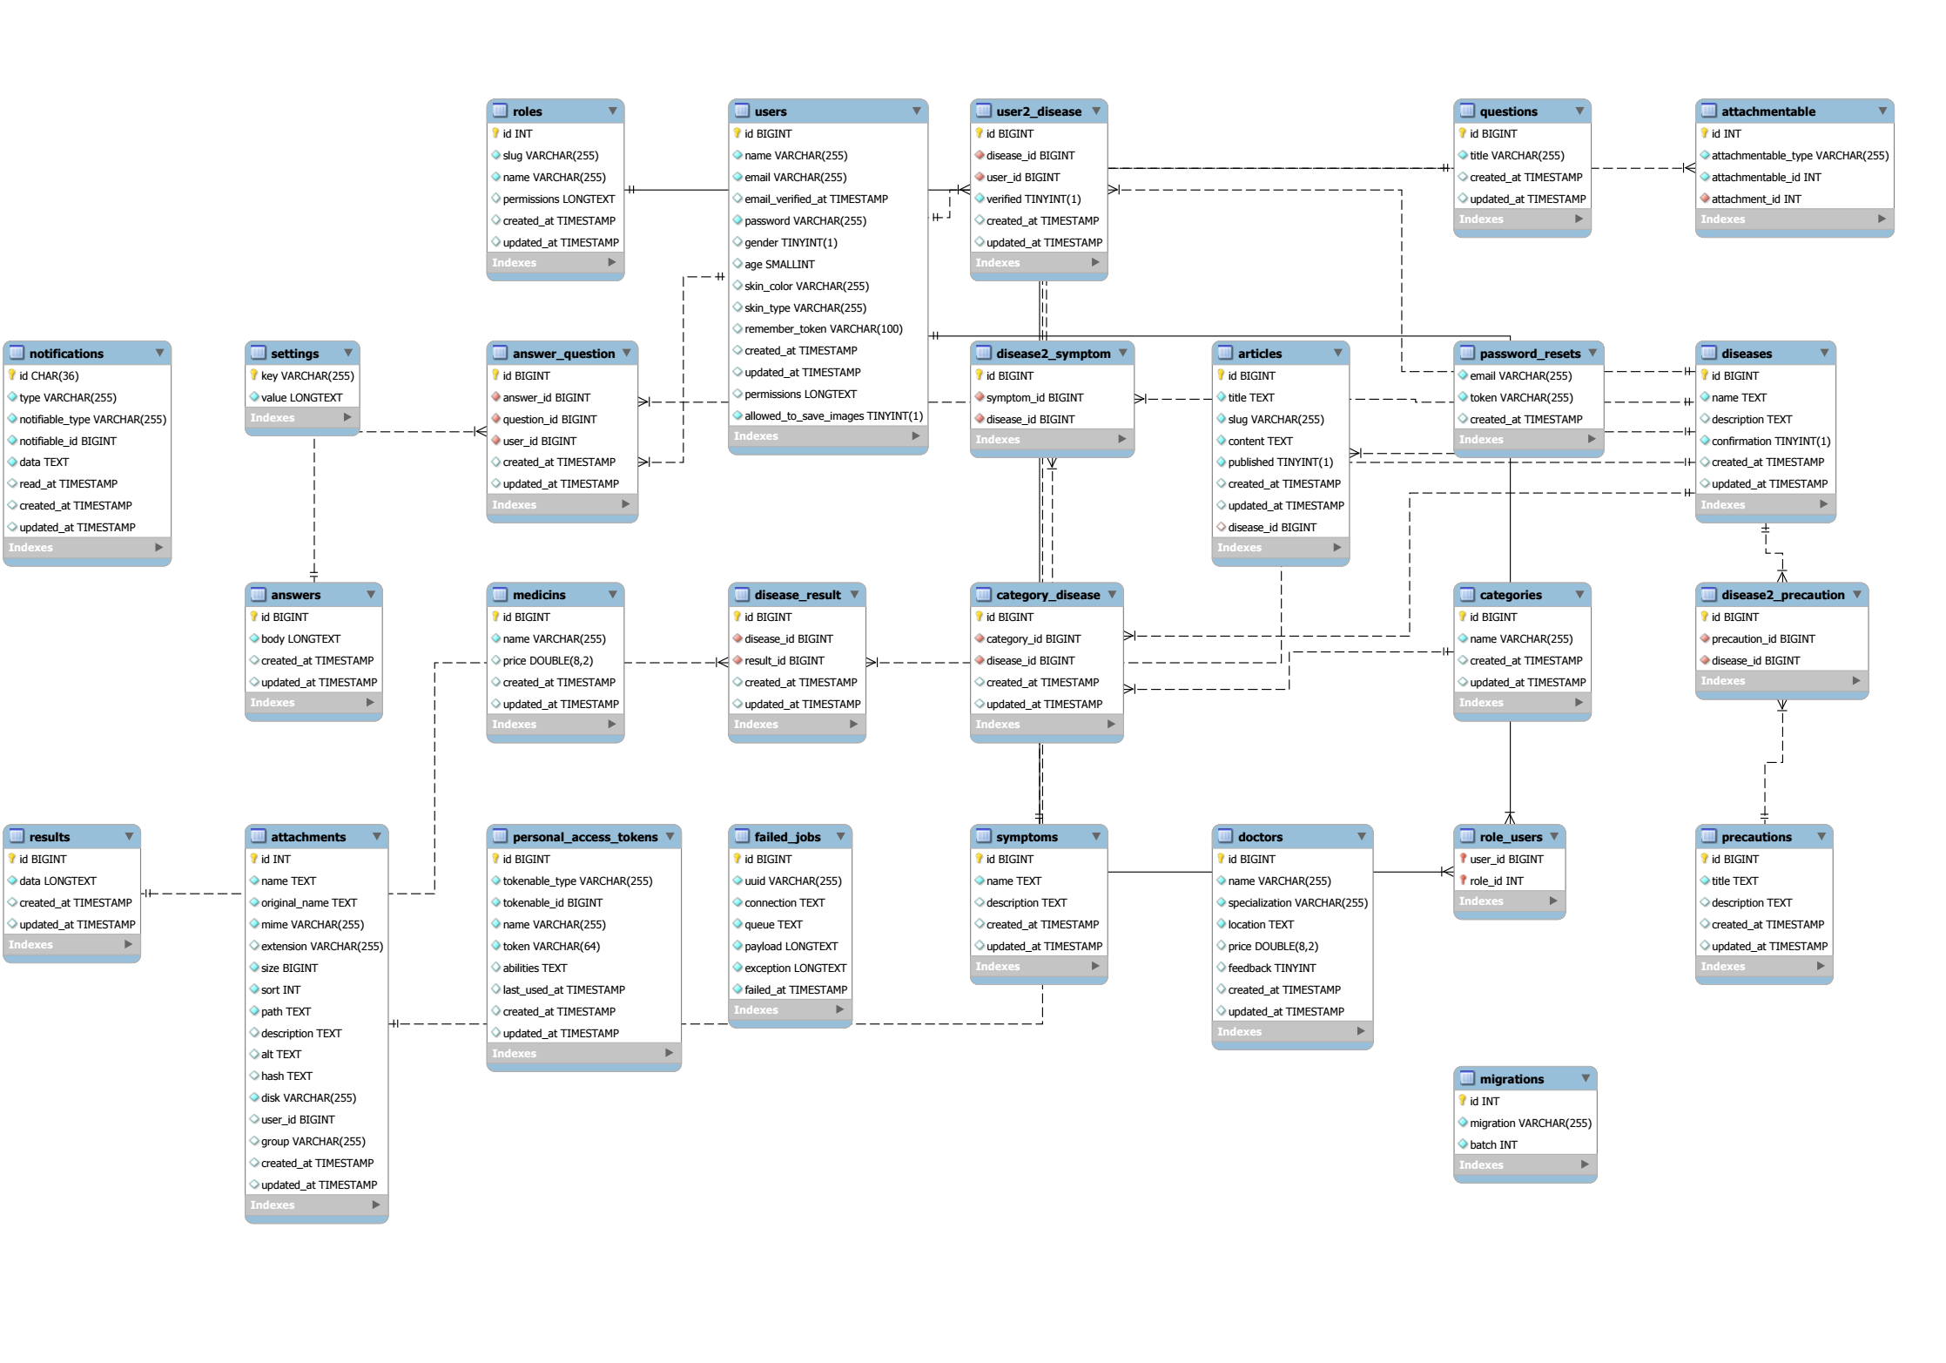Each entity contains attributes with identifying the foreign key and the primary key.

Figure 4.2 Database design

**4.3 Interface Design**

We seek to minimize time and efforts needed by the user to do some action. So, the interface

of the application should be clear, easy to use, easy to understand, and smooth .The following

subsections show the designed views of the mobile application and description of each view.

**4.3.1 Profile**

After login successfully, the application will open the user’s profile. The profile page

contains user information. The user can logout button at bottom.

|  |  |
| --- | --- |
| • **Log in Page**     1-First input field: used for entering username.   2-Second input field: used for entering password.   3- Login button: Confirm access to your account.   4- Facebook button: used to (login or signup) with your Facebook account.   5-Google plus button: used to (login or signup) with your google plus account.   6- Signup button Navigate to signup page (if you are not registered yet). | |
| • | **Signup page(register):**  1- First input field: used for entering Email. |
| 2- Second input field: used for entering password.  3- Third input field: used for entering password conformation.  4- Signup button: Confirm registration process.  5- Facebook button: used to (login or signup) with your Facebook account.  6- Google plus button: used to (login or signup) with your google plus account. 7- Login Navigate to login page (if you already have an account). | |

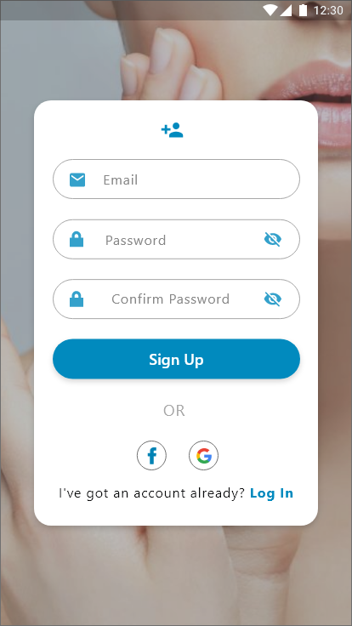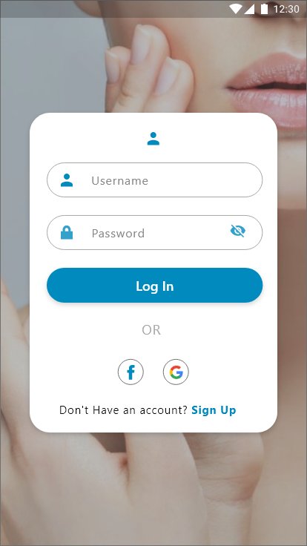

Figure 4.3 login and signup pages

**4.3.2 Home page**

In home page, user can Start New Case By Navigate to Scan page and Select photo to scan   
and see his History, user can Navigate to search page and profile page.

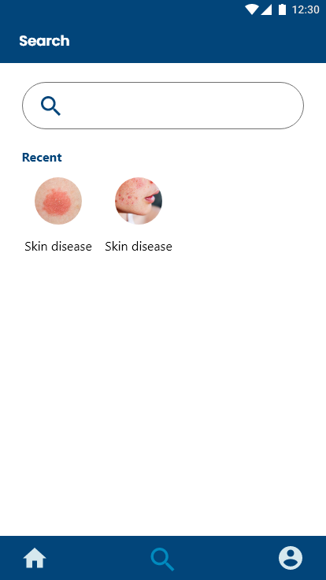**4.3.3 Search page**

The user can Search for a disease by name and get disease  
information ,Self-care, Medicine can be used ,  
and Additional information

**4.3.4 Scan page**

**4.3.5 Questions page**  
After take image , Some questions appear to help diagnose the Case ,These questions are multiple choice  
After Answer it , we go to Result page

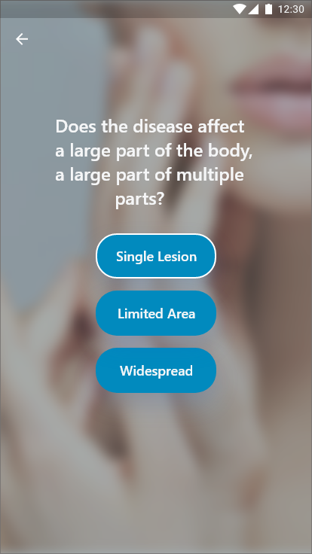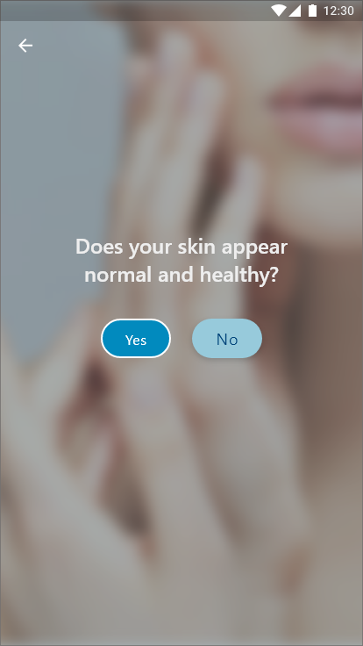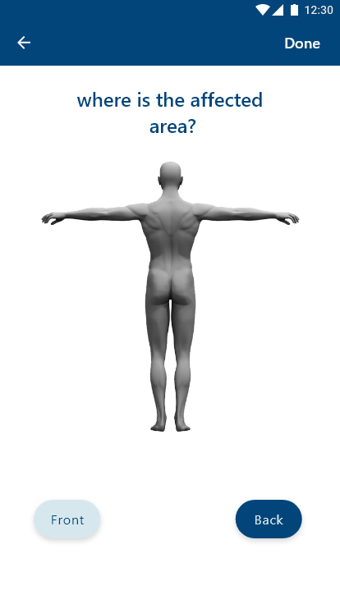

|  |  |
| --- | --- |
|  |  |

**4.3.6 Result page**

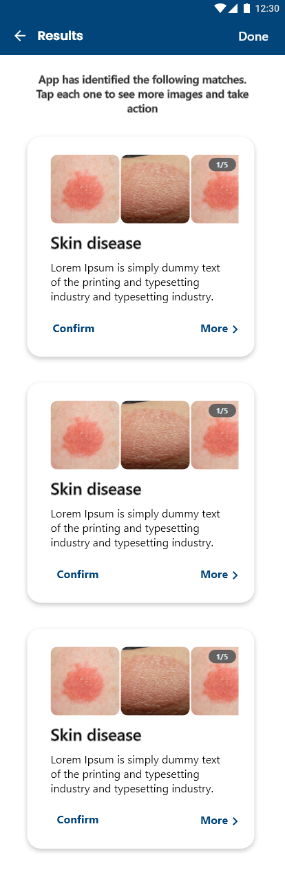After Scan image and Answer the questions , The Result is given to the nearest 3 possibilities that correspond to the symptoms.

**Each result contains:**  
- A group of pictures of the disease.  
- Disease name.  
- Short description.  
- Confirm button “That diagnosis is correct” ,   
 you can also unconfirm it.  
- Button ‘more’ Navigate us to **Disease page**.

|  |  |
| --- | --- |
|  |  |

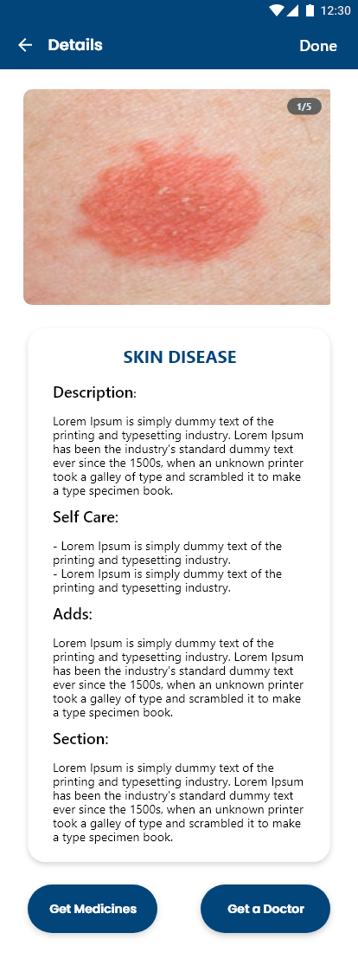**4.3.7 Disease page** This page contain :  
- Slider to Show disease images  
- Disease name  
- Description for this disease  
- Some advices like :  
 * Self Care  
 * Medicines that can be used  
 * When you should go to doctor  
- Additional information (causes and places of spread)  
- Another disease that have the same symptoms  
  
- Button for order Medicine (Get Medicine)  
 **>** this button Navigate to Medicines page  
  
- Button to book a doctor (Get Doctor)  
 **>** this button Navigate to Doctors page

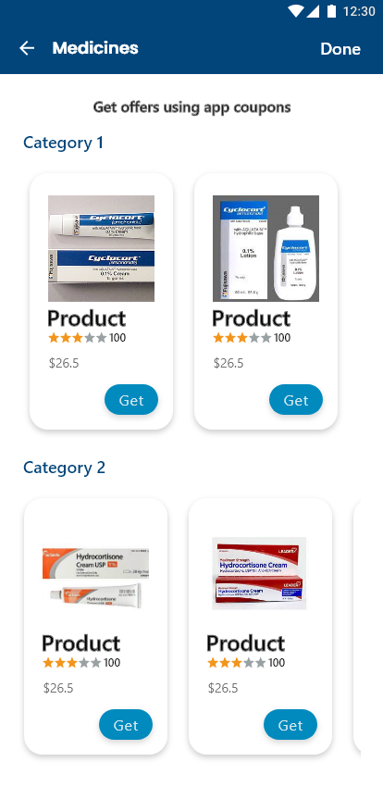**4.3.8 Medicines page**

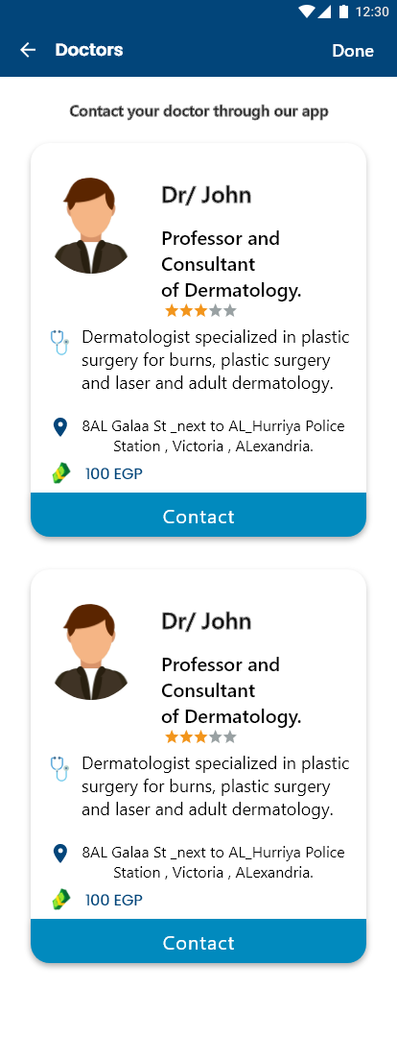This page Divided into Categories:  
**-** Each Category contain list of medicines that belong   
 this category and some information about medicine like:  
  
 * Medicine Image  
 * Medicine name  
 * price  
 * and Button to Get it (Get)

**4.3.9 Doctors page**

This page contain :  
 - A Collection of Dermatologists and information about each one   
 * Doctor name  
 * Description about him   
 * His location  
 * Price  
 * Rating from 5  
- Contact Button to communication with him

**4.4 Summary**

In this chapter we make the reader take a look at our system design. Section 4.1 provides

class diagram for DERMAI . We also designed in Section 4.2 the tables of the database. And, we

showed the reader the interface design of the application with a description of its usage in

Section 4.3. We can now start the implementation process. In the next chapter, we will map

our system design to implementation.